AI ASSISSTED CODING LAB-7.3
Name:k.Dhana sri
Rollno:2303a52153 batch:41
Task 1: Fixing Syntax Errors
You are reviewing a Python program where a basic function definition contains a syntax error.
Code with syntax error
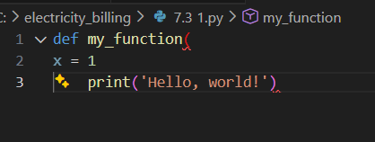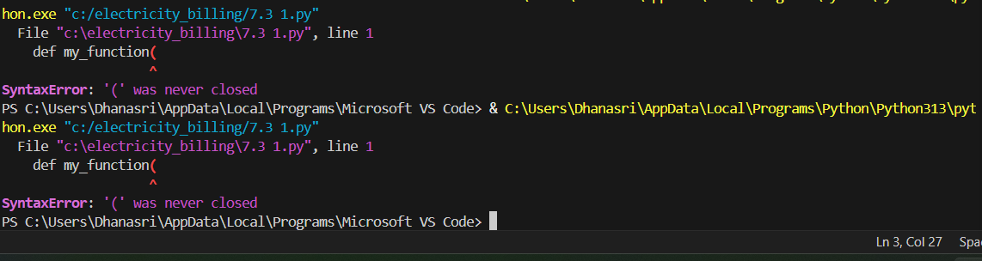
Error Identified by AI •
Type of Error: SyntaxError
• Reason: Python requires a colon (:) at the end of a function definition line.
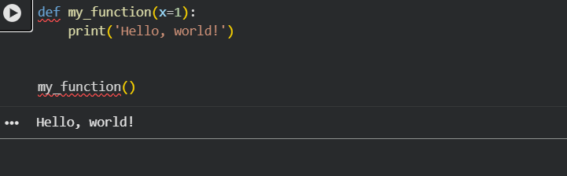
Explanation by AI:
The AI detected a syntax error because the function declaration line did not end with a colon. In Python, the colon indicates the start of an indented code block. Without it, the interpreter cannot parse the function body.
• AI-generated explanation of the fix
Task 2: Debugging Logic Errors in Loops Scenario You are debugging a loop that runs infinitely due to a logical mistake.
Requirements Code with errors
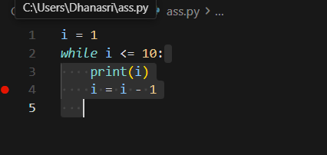
Error Identified by AI Type of Error: Logical Error Reason: The loop variable is decremented instead of incremented, so the condition i <= 5 is always true.
Code debugged by ai:
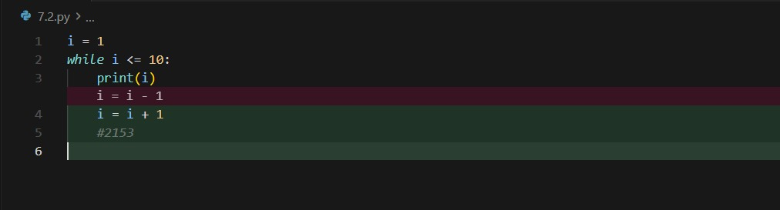
Output:
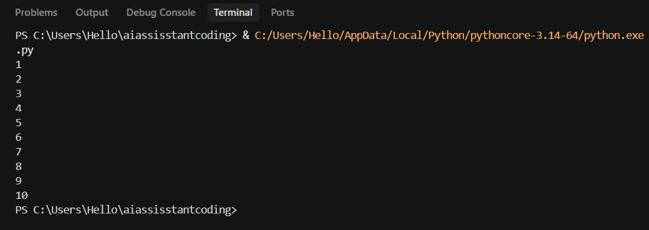
Explanation by AI:
The loop condition depends on i increasing toward a stopping point. Decrementing i causes it to move away from the termination condition, resulting in an infinite loop.
Task 3: Handling Runtime Errors (Division by Zero) Scenario A function crashes due to division by zero.
Buggy code
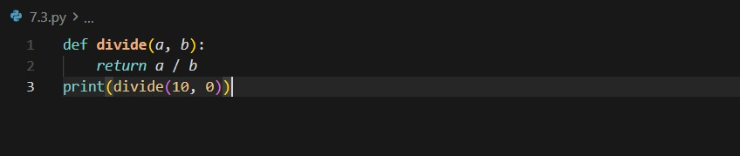
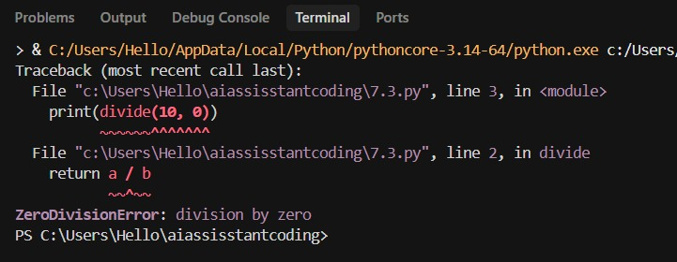
Error Identified by AI
• Type of Error: Runtime Error (ZeroDivisionError) • Reason: Division by zero is mathematically undefined.
Debugged code
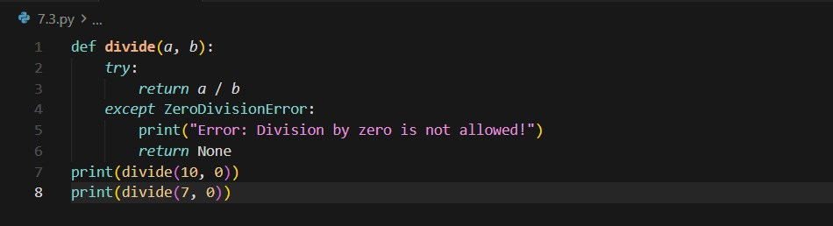
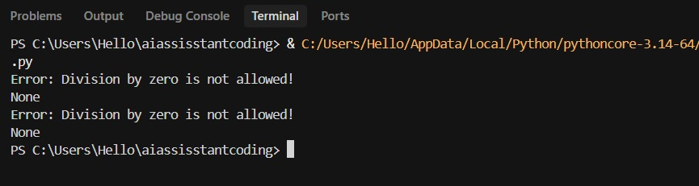
Explanation by AI :
The AI added exception handling using try-except to prevent program termination. This ensures graceful handling of invalid input instead of crashing the program.
Task 4: Debugging Class Definition Errors Scenario A Python class constructor is incorrectly defined without the self parameter.
Buggy Code
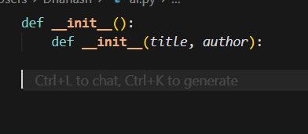
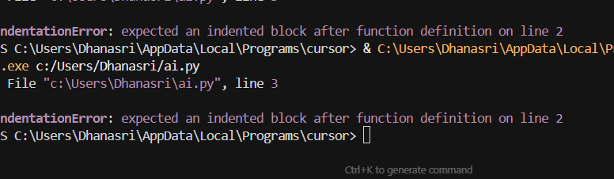
Error Identified by AI •
Type of Error: TypeError / Object-Oriented Error
• Reason: The self parameter is mandatory for instance variable access.

Debugged code
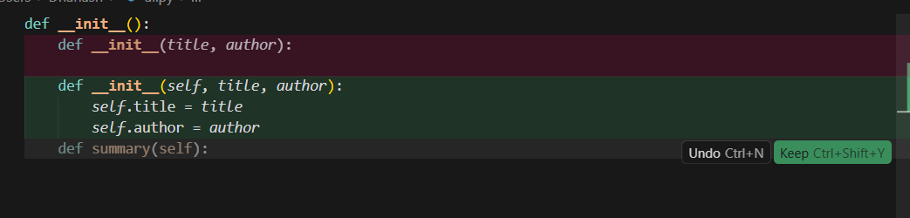
Explanation by AI :
The self parameter represents the current object instance. Without it, instance variables cannot be properly assigned or accessed. Task 5: Resolving Index Errors in Lists Scenario A program crashes when accessing an invalid list index.
Buggy Code
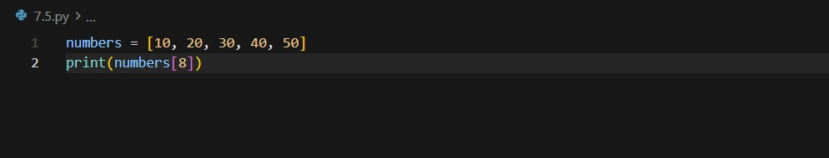
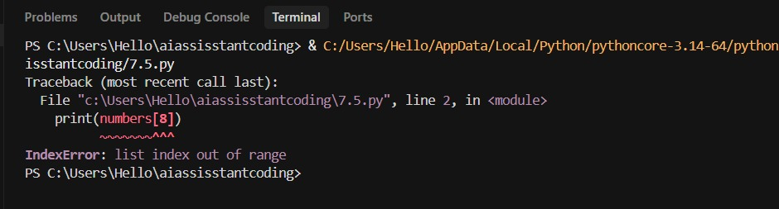
Error Identified by AI
• Type of Error: IndexError
• Reason: Index is outside the valid range of the list.
Debugged code:
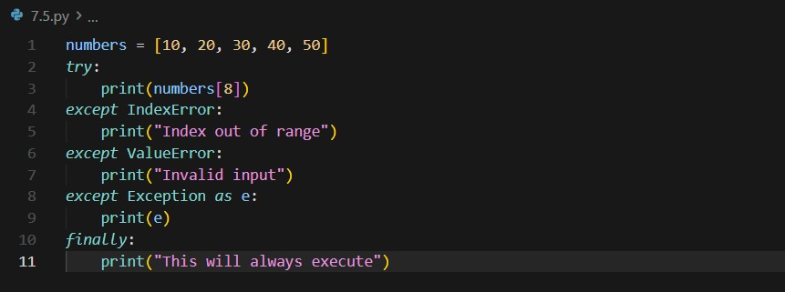
Explanation by AI The AI suggested two safe approaches: checking the index against list length or handling the exception using try-except. Both prevent program crashes.
Output:
